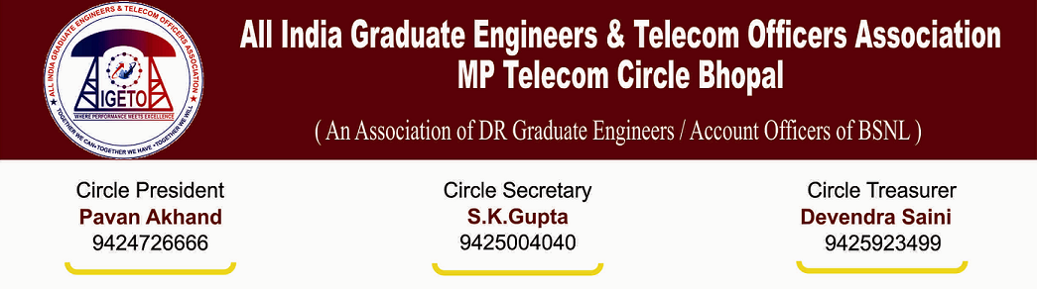
AIGETOA/MP/13-14/45 Date: 04/03/2014

To,
Shri N K Yadav
Chief General Manager
M.P. Telecom Circle, Bhopal

Subject: Randomness in Salary cut of direct recruit’s executives for the period of agitation during the
month of July-Aug-2013 and Feb-2014 –Reg.

Respected Sir,
It is to bring to your kind notice that various SSA in M.P. Telecom Circle have cut the salary of direct recruit’s executives for the month of July-August-2013 and Feb-2014 purely on random basis and without any prior intimation / communication. It is worth to mention that Direct recruits executives were absent from the duties during the agitation call of AIGETOA CHQ, by applying the leave in the month of July-August-2013 and in the month of Feb-2014. Leave were not sanctioned with the reason best known to the authority even for the period for which there was no order from corporate office/Circle Office to not sanction the leave. Sir, as per the provision of the company act and Indian constitution every employee has full right to protest against injustice meted out to them in the organization and of course they are liable to pay the penalty for the same as per the rules and guidelines. We wish to submit following facts on randomness committed by SSAs violating all the rules and guidelines while cutting the salary.
- In some SSA controlling authority did not serve show cause notice and in some SSA have served the show cause notice but did not wait for the reply and without passing any order and without any prior or post information DDOs have cut the salary without any base.
- Executives in BSNL have 24X7 hrs responsibility hence they have to complete their pending work after resuming their duty for the period of absent hence mere absentee statement cannot be the base for disbursing the salary of the executives but all DDOs of the SSA have cut the salary on the basis of absentee statement.
- HRA and EPF is statuary provision and comes under fringe benefit hence same cannot be cut while applying “No work No pay” principle for the period of agitation but DDOs have calculated proportionate basic pay hence HRA and employer contribution towards EPF is also made less on proportionate basis. Even employee contribution towards EPF is also made less on the proportionate basis. Our said statement is substantiating with the fact that employees living in government quarter cannot be vacated for the agitation period hence HRA for employees living in private quarter cannot be deducted. Pension contribution for the employees covered under Rule-37A of CCS pension rule cannot be made less on account of agitation period.
- SSA can apply “No work No pay” principle only after the date on which administrative order is issued by the competent authority but many SSA have deducted the salary from the date much before the administrative order is issued.
- Salary was cut in such a hurry and vindictive manner that they have not even followed the very basic principle of minimum pay in hand for survival of family and dependents. To maintain minimum pay in hand they could have deducted salary in installment but even income tax has been deducted in tune of Rs 5000.00 to 10000.00 but net pay in hand is less than Rs. 500.00
Considering the facts submitted above I request your god self to kindly instruct the authority to take following action:
- To supply the detail and certified copy of Rules/Guidelines to this association regarding applicability of “No work No pay” principle.
- To refund the salary by adjusting the leave in account for the period administrative order in respect of “No work No pay” does not exist.
- To refund the HRA along with interest @18% per month deducted while applying “No work No pay” for the period it is deducted.
- To deposit the EPF contribution for both employee and employer share for the period it was made less contribution while applying “No work No pay” along with interest and penalty as per the provision of Para-32 of EPF act 1952.
- To fix the responsibly for such randomness in cutting the salary and initiate suitable disciplinary action against them.
There are already hundreds of anomalies with our pay and EPF due to such randomness, resolution of which has become more and more complicated with time. This association cannot allow further such randomness in our pay and EPF hence you are kindly requested to take suitable and expeditious action in this regard to resolve the issue within a week of time else this association is bound to initiate organizational action to protect our pay, HRA and provident fund.
We are quite hopeful that issue will be resolved amicably under your kind leadership and intervention.
Thanking you.
Your’s faithfully,

(S K Gupta)
Circle Secretary, AIGETOA MP

Copy to:
- The Sr. GM(Admin/HR),O/O CGMT MP Circle Bhopal.
- General Secretary, CHQ AIGETOA with request for persuasion in BSNL CO New Delhi

