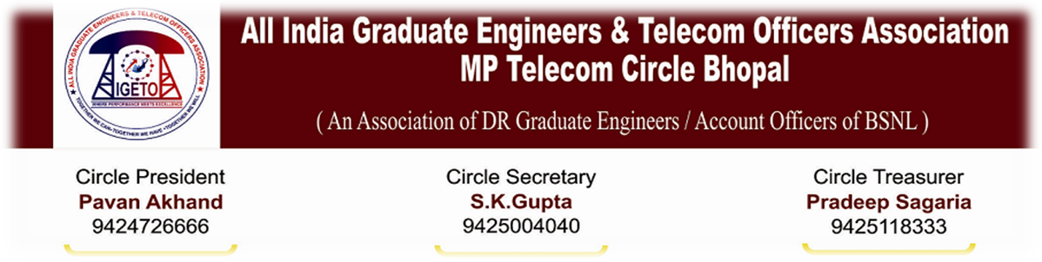
No. AIGETOA/MP/13-14/13 DATE: 19/08/2013

NOTICE FOR CIRCLE EXECUTIVE COMMITTEE MEET
As per provision of Constitution of AIGETOA Circle Executive Committee meeting is hereby notified to be held on 1st September 2013, Sunday at Bhopal. All Circle Executive committee members/DS/DP/District coordinators are cordially invited to attend this meeting.
Venue of Meeting: Regional Science Centre Banganga Road Bhopal. Meeting will be held between between 10.00 AM to 06.00 PM
Agenda of Meeting: For election of delegates for attending AIC to be held on 14th and 15th September 2013 at Jaipur.

All District Secretaries are requested to note the following points strictly.

- All District Secretaries are requested to come with proper financial statements, audited account till date, details regarding paid subscription and list of members of the district.

- Circle/ CHQ Quota must be paid up to July’ 2013.

- A general body meeting must be called before proceeding for CEC Meeting to finalize resolutions of District branch to be handed over in the CEC.

- All District secretaries and Circle Office Bearers should necessarily attend the CEC Meeting. If in any case, District Secretary is not able to attend the said meeting, he must authorize to any member of the branch with prior permission.

(S K Gupta)
Circle Secretary, AIGETOA MP

Copy to:
- Shri Pavan Akhand, President AIGETOA MP Circle with request to preside over the meeting.
- All Circle Executive Committee members to attend meeting as per schedule.
- All District secretaries/District President to attend meeting as per schedule.
- The Sr. GM(Admin/HR) for kind information please.

