ALL INDIA GRADUATE ENGINEER TELECOM OFFICERS ASSOCIATION
(An Association of Gr. Er. Telecom Officers of B.S.N.L./M.T.N.L.)
Regd. Office: Office No. 4 & 5, Near Sethi Hospital, Bawal Chowk, Rewari-123401 (Haryana)
Website: www.aigetoachq.org
President General Secretary
N. Shilohu Rao S. K. Saini
No. 36,II Street, Kamraj Nagar 283-L, el Town,
Villivakkam, Chennai-600049 (TN) Rewari-123401 (Hr.)
Mobile: +91-9444442255 ile: +91-9416010099

Ref No: CHQ/AIGETOA/ GS1 Dated.29-08-08

To
The CMD,
BSNL,
New Delhi.

Respected Sir,
Subject: New General Secretary –Reg

I would like to inform you that Shri Sanjay Kumar Saini has resigned from the post of GS, AIGETOA due to some personal reason. Our CHQ Executive Body and Circle Executive Bodies have unanimously elected Shri R.P. Shahu, Jt Sec (central), CHQ, AIGETOA as our new General Secretary. He has been authorized to communicate on behalf of the association in all the matters and issues pertaining to our members with the management and authorities concerned of BSNL and other authorities out side BSNL towards the welfare of our members. I request you and the management of BSNL to communicate to our new General Secretary on all the issues pertaining to our association with immediate effect. The address and contact details of our new GS are given below.
Shri R.P. SHAHU,
GENERAL SECRETARY,AIGETOA,
NO.3/10, DOORSANCHAR COLONY,
NAVRATAN BAGH,
INDORE – 452001. (M.P)
Mobile No. 09424051555.

Thanking you,
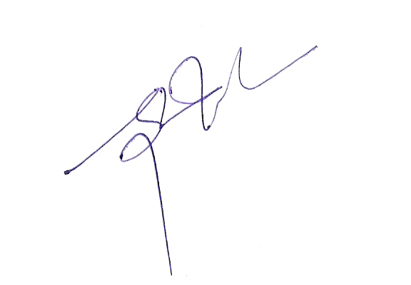
With regards

Shilohu Rao
President, AIGETOA
Copy to:
- Director (HRD), BSNL, New Delhi.
- DDG (SR), BSNL, New Delhi.
- All CGM’s of BSNL units

