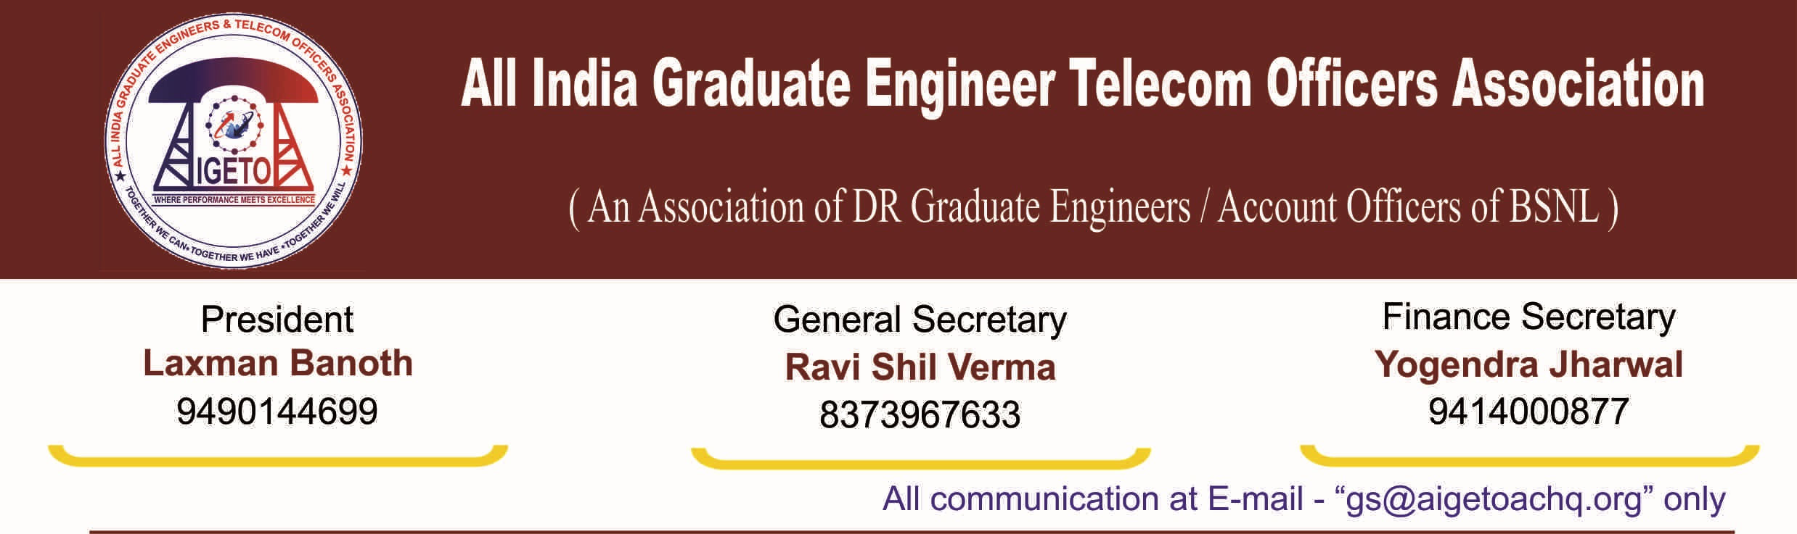
No. GS/AIGETOA/2016/31 Dated 21.12.2016

NOTICE FOR CENTRAL EXECUTIVE COMMITTEE MEET OF AIGETOA

As per provisions of the constitution of AIGETOA and subsequent to discussion/decisions among CHQ/CS/CP, Central Executive Committee Meet of AIGETOA is hereby notified to be held on 8th & 9th January 2017 at Faridabad. The meeting will be held as per the following schedule:
Date & Time : 8th & 9th January ’2017 (Sunday & Monday) from 10:00 to 18:00
Venue : Hotel Aashirbad, Neelam Bata Road, NIT, Faridabad

Agenda of the Meeting:
- Deliberation & strategy towards settlement of Burning HR issues to BSNL Recruits – Discussion, Resolution & Action Plan.
- Organizational matters of the Association - Discussion, Resolution & Action Plan
- Strategic Alliances with other Service Associations of BSNL - Discussion, Resolution & Action Plan.
- Discussion on Anti Associational Activities of some members of the association.
- Legal aspects on various issues & efforts by AIGETOA- Discussion, Resolution & Action Plan.
- Any other agenda item as opinioned by the house under permission of the chair.

Sd/-
[Ravi Shil Verma]
General Secretary

Copy to:
- The District Registrar Firms and Society, Faridabad, Haryana for kind information.
- The Sr GM (SR), BSNL HQ, N. Delhi for kind information and direction for SCL to delegates.
- Sri Laxman Banoth, AIP/AIGETOA with a request to preside over the meeting.
- Sri R.P. Shahu, with a request to attend the meeting with reference to discussion on agenda points.
- All CHQ Members to make it convenient to attend the meeting as per schedule.
- The CS/CP of all Circles to attend the meeting as per schedule.

