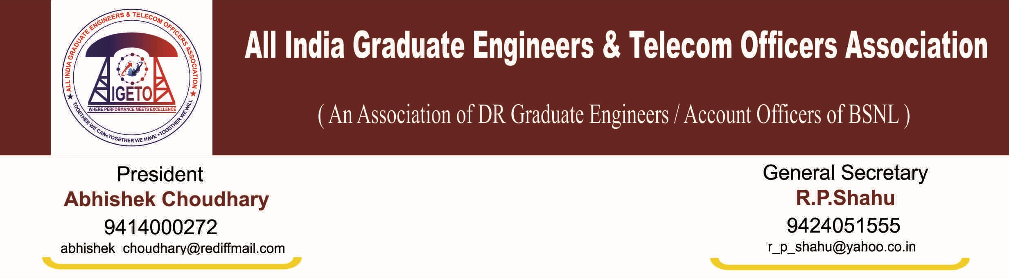
No: CHQ/AIGETOA/435 Dated: 23nd July- 2013
To,
Shri VAN Namboodiri
Convener for forum of Union and Association
Subject: An appeal seeking your kind support for our ongoing organizational activity against non resolution of various long pending genuine issues in respect direct recruits of BSNL.
Dear Sir,
This association has been trying since long time to resolve the various genuine issues through the mutual negotiation but it is regret to mention that management is completely failed to resolve the very genuine issues despite several written assurance. This association is left with no option but to serve the notice for agitational activity with following demand.
- Finalization of standard pay scale as directed by DPE followed by 2nd PRC i.e. E2 for JTO equivalent and E3 for SDE equivalent with additional increment to executives recruited on or after 01-01-2007 to maintain the parity between executives recruited before 01-01-2007.
- Implementation of 30% superannuation benefits in respect of direct recruits executives as directed by DPE followed by 2nd PRC..
- Stop external DGM/MT recruitment hence scrape the RR, same must be recruited within among internal executives and implement the time bound functional promotion instead financial upgradation on the basis for stringent performance and qualification as of top leading CPSEs to fill the gap at middle level executives.
- Resolution of EPF anomalies in respect of direct recruits.
- Immediate cancellation of mass displacement executed in posting order issued in promotion against LDCE (33% quota) for SDE (T) held on 4th March-2012 from some circle like AP, Orisa, Punajab. Maharashtra, MP and KTK. Execute the longest stay list to maintain the shortfall of SDEs in some circles.
- Maintain uniformity in first time bound upgradation i.e. four years in respect of all executives.
- At par facilities to this association as of SNEA/AIBSNLEA.
Organizational activity is as under:
- From 15th-July-2013 to 20th-July-2013 -Mass signature campaigning and working with black batches.
- From 22nd July-2013 onwards: mass leave.
- From 29th onwards: mass demonstration at BSNL corporate office New Delhi.

Your kind will appreciate that demand submitted above is not just a demand but all are our basic rights and resolution of above issues is in no way affecting negatively to any other section of employees. In fact non-resolution of most of the issues above is also badly affecting the direct recruit’s non-executives today or tomorrow.
Your kind would agree with our views that non resolution of above issues since long time is creating high level of unrest and demotivation in the mind of young executives and non-executives which ultimately affecting badly the performance of the company.

Your kind support with all constituent of forum is highly solicited.

S/d
(R P SHAHU)

General Secretary

