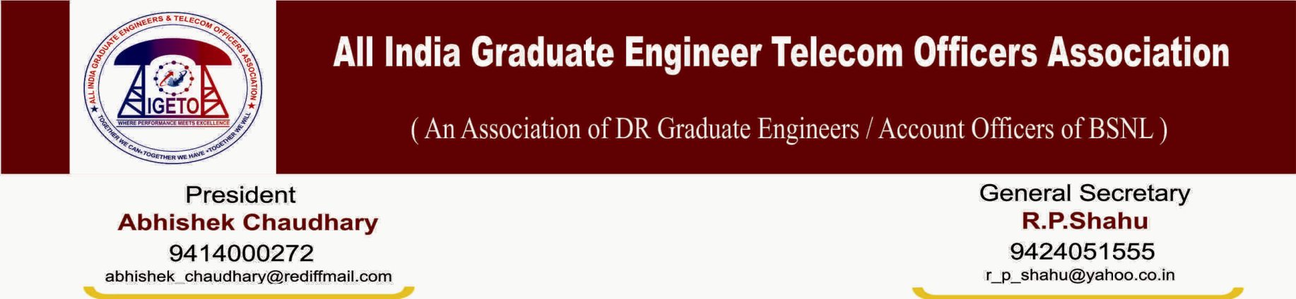
No: CHQ/AIGETOA/451 Dated: 9th Sep-2013
To
The Sr. G.M. (SR)
BSNL Corporate Office
New Delhi

Sub: Regarding Granting of special CL to Central Executives Committee and Electoral Collegiums from the Circles to attend the Annual General Meeting of the Association to be held on 14th and 15th Sep-2013 at Jaipur, Rajasthan.

Respected Sir,
Kindly refer to our letter No. CHQ/AIGETOA/442 dated 12th Aug-2013 vide which notification for conducting Annual General Meeting as per the constitutional provisions of the AIGETOA has been issued.
In the Annual General Meeting, the Central Executives Committee i.e. Governing Body of AIGETOA CHQ is to be elected by an Electoral Collegiums consisting of 5 Circle Representatives of AIGETOA from each Telecom Circle.
In this regard, it is kindly requested to issue necessary instructions to all the field units to grant special CL to the current Central Executives Committee (CHQ) Members (List Attached herewith and marked as Annexure-1) and a maximum of five Circle Representatives (list to be submitted to the Circle Heads by our Circle Secretaries respectively) for 14th and 15th Sep-2013 along with to and fro journey time, so that they can attend the AGM and elect new Central Executives Committee of AIGETOA CHQ. This will enable us in smooth conduction of the AGM and proper democratic representation from the respective circle bodies.

Thanks for your kind consideration.

Sincerely yours

(R P Shahu) General Secretary

Annexure-1

List OF Central Executives Committee i.e. Governing Body of AIGETOA CHQ

SN | HRMS | Name of the Office Bearer | Circle of Posting | SSA | Post held in AIGETOA
1 | 200304883 | Sh. Abhishek Chaudhary | Rajasthan Telecom Circle | Sriganganagar | President
2 | 200204093 | Sh. Ravi Shil Verma | BSNL CO Delhi | BSNL CO | Vice-President I
3 | 200304883 | Sh. Abhishek Chaudhary | Rajasthan Telecom Circle | Sriganganagar | Vice-President II
4 | 200206440 | Sh. R P Shahu | MP Telecom Circle | Sidhi | General Secretary
5 | 200200178 | Sh. Amit Roy | BSNL CO Delhi | BSNL CO | Asst. General Secretary I
6 | 200401316 | Sh. Surinder Kumar | Kurukshetra, Haryana | Karnal | Asst. General Secretary II
7 | 200300804 | Sh. Yogendra Jharwal | Rajasthan Telecom Circle | Jaipur | Finance Secretary/Treasurer
8 | 200300802 | Sh. Pavan Akhand | MP Telecom Circle | Bhopal | Web Secretary
9 | 200305669 | Sh. Ajay Kaswan | Punjab Telecom Circle | CMTS Nodal Centre Chandigarh | Organizing Secretary
10 | 200202766 | Sh. Vaibhav Goyal | UP (West) Telecom Circle | Hatras | Joint Secretary-Central
11 | 200200036 | Sh. Ashok Acharya | Odisha Telecom Circle | Bhubaneswar | Joint Secretary-East
12 | 200203662 | Sh. Kishor Gaikwad | Maharashtra Telecom Circle | IT Circle Project | Joint Secretary-West
13 | 200301242 | Sh. Sathya Vardhana Rao | AP Telecom Circle | Ongole | Joint Secretary-South
14 | 200201352 | Sh. Gaurav Singh Aulakh | Punjab Telecom Circle | Chandigarh | Joint Secretary-North
15 | 200201368 | Sh. Rajender Singh | BSNL CO Delhi | BSNL CO | Asst. Finance Secretary
16 | 200304715 | Sh. S K Saini | Haryana Telecom Circle | Rewari | Chief Adviser of CHQ
17 | 200300395 | Sh. Sharada Prasad | UP (Eest) Telecom Circle | Lucknow | CHQ Auditor
18 | 200303342 | Sh. Dinesh Roy | Kolkata Telecom District | Kolkata | Media Spokesperson/Coordinator

