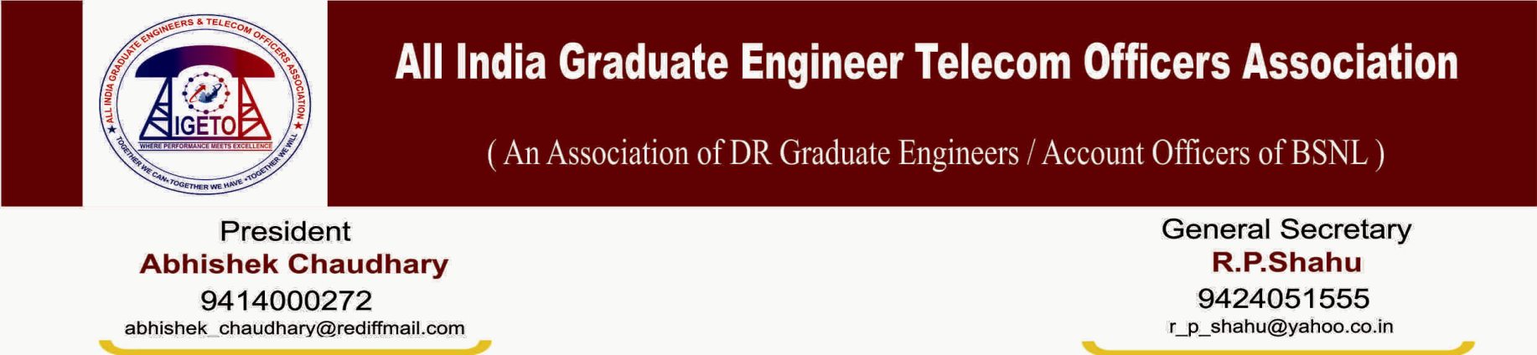
No: CHQ/AIGETOA/450 Dated: 6th Sep-2013
To
Shri R.K. Upadhyay
CMD, Bharat Sanchar Nigam Limited
New Delhi.

Sub: Invitation as Chief Guest for the “Open Session” to be organized on 14th Sep-2013 at Hotel Clarks Amer Jaipur on the occasion of our 3rd AIC/AGM

Respected Sir,
It is an honor to have your distinguished presence as a Chief Guest on our incoming “Open Session” to be organized at Hotel Clarks Amer Jaipur on 14th Sep-2013 on the occasion of 3rd All India Conference/Annual General Meeting.

Sir, We believe that being the dynamic leader and head of the organization you are the best choice for the event where hundreds of young qualified executives from nook and corner of the BSNL will be privileged and motivated with your valuable presence and speech on the topic.

Theme of the open session is: “Regaining the pristine glory of BSNL- Steps, Initiatives and the Roadmap ahead”

Should you permit our kind request, we will let you know of the schedule as per your convenience. Thank you for your valuable time and looking forward to your favorable response.

Sincerely yours

(R P Shahu) General Secretary

