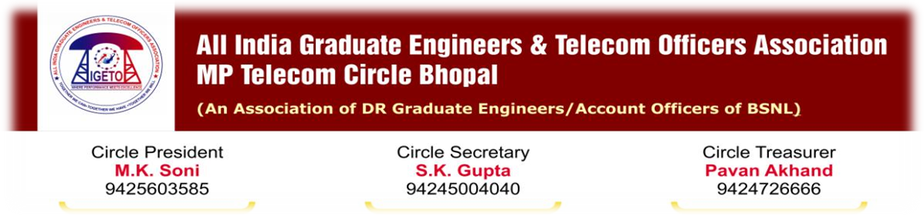
No. AIGETOA/MP/10-11/134 DATE: 29/08/2011

To,
Shri N. K. Yadav,
Chief General Manager,
M P Telecom Circle, Bhopal.

Subject: Notice for agitational activity due to deliberate ignorance of issues of DR Executives of MP Telecom Circle.

Dear Sir,
I regret to mention that despite several attempts to resolve the genuine issue related to members of this association through amicable ways, management has not shown any interest and completely failed to resolve.
This association is very much concern about the productivity of the company but at the same time it is also concern about members welfare and securing their rights as primary responsibility hence, tried every possible ways to avoid any such unpleasant situation at this crucial juncture of the company but now continues ignorance and deliberate attempt of GM (Admin) to deprive direct recruits of this company has left no other ways then serving the notice of agitational activities.
Seeking resolution:
- Immediate transfer of GM (Admin) Sh Prabhash Singh as he has already passed sufficient time on the post against the transfer policy and his activity is totally biased and against the direct recruits of this company.
- Enquiry into the vested interest of GM (Admin) for deliberate attempt to deprive direct recruits delaying first time bound upgradation on pretext of nonsense clarifications and transfer and posting of executives during his tenure. This association is ready to submit all the facts before the enquiry committee.
- Immediate issue the arrear with interest of first time bound upgradation either by completing DPC or through advance payment by taking suitable undertaking.
- Immediate resolution of EPF issues either by making special task force team or issuing necessary order allowing leave and TA/DA to affected members so that they can pursue their issues with EPF authority.
Agitational activities:
- 5th Sept 2011 onwards: Wearing black badges & Non-Cooperation Movement.
- 15th Sept 2011: Lunch our demonstration at district and Circle Head quarters.
- 20th Sept 2011 till the resolution of issues : Mass demonstration and Dharna at Circle Office Bhopal till the resolution of issues.
This association is still hopeful that management will take positive note on the demand of this association under your great leadership and will surly avoid such situation to take place by resolving the issue in due time.
With Regards, 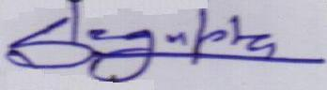
(S. K. Gupta)
Circle Secretary, AIGETOA-MP
Encls:
- Corporate office letter no 400-61/2004-Pers.I (pt.II) Dated-18/03/2011
- Circle Office letter DPC/TBP/Executives/09-10/148,Dated-21/04/2011
- Corporate office letter no.400-27/2010-Pers.I,dated-29/07/2011
- Circle Office letter No.DPC/Executive/TBP-IV/2011-12/29,Dated 17/08/2011
Copy to:
- GM (Admin/HR), O/o CGMT MP Telecom Circle.
- All SSA Heads MP Circle.
- Shri R P Shahu, General Secretary, AIGETOA.

