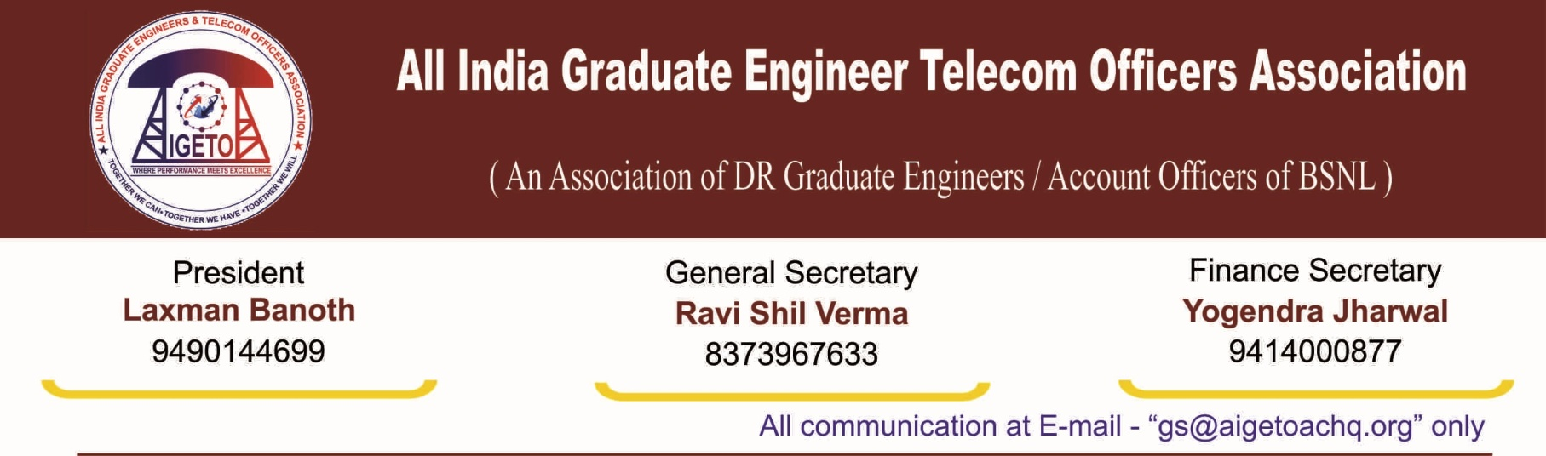
No. GS/AIGETOA/2018/8 Dated 04.05.2018
To,
Smt. Sujata Ray,
Director (HR),
Bharat Sanchar Nigam Limited
Janpath, New Delhi

Sub: Non-clearing of the Rule-08 waiting list in Karnataka Circle even after getting sufficient JTOs.
Ref: No.5-32/2017-Estt-IV/Rule-08 dated 23rd Feb 2017

Respected Madam,

This is to bring to your kind notice that as per the letter referred above, BSNL Corporate Office has issued guidelines and procedure for maintaining waiting list for transfer under Rule-08 to all the Telecom Circles.
We are thankful to your good self that after the kind intervention from BSNL CO under your guidance, most of the circles have cleared maximum number of Pending Rule-8 cases. However, Karnataka Circle yet remains an exception in this regard. Even after almost double the number of wait listed cases for Karnataka Circle has joined in the circle, the Rule-8 cases pertaining to Karnataka Circle have yet not been cleared and people are waiting for the long awaited transfer despite passage of almost 8 to 10 years.
As per the Para 6 of the letter under reference, waiting list is to be reviewed on quarterly basis and maximum number of Rule-08 transfers should be considered as and when new JTOs join on account of promotion or direct recruitment.
In Karnataka Circle, the number of Rule-08 cases considered so far is 153 since year 2014 and the number of new JTOs who have joined in recent times is 539. The waiting list still has 190 candidates. The details of the new JTOs joined vis-à-vis the waiting list is as mentioned below:
NUMBER OF  LICE JTOs JOINED | NUMBER OF  GATE JTOs | RULE-08 CONSIDERED SO FAR | PRESENT WAITING LIST
328 | 211 | 153 | 190

Our Karnataka Circle chapter has been representing this issue to CGMT Karnataka on many occasions but Karnataka Circle administration is not willing to consider clearing the Rule-08 waiting list on 1:1 basis i.e. incoming JTOs on LICE/ GATE: Rule-8 JTOs. Due to this, many JTOs who have completed more than 8 to 10 years of service in Karnataka Circle and waiting to join their Home circle are deprived of their chance.
In view of the above, your kind intervention is solicited for issuing necessary instructions to Karnataka Telecom Circle for doing the needful as per the directions issued by BSNL CO vide letter under reference and address this long pending issue Karnataka Circle.

With Regards

(Ravi shil Verma)
GS, AIGETOA

Copy to:
1. GM (SR), BSNL CO, New Delhi for kind information and n/a please.

